Assignment 5

# Afia Fahmida Rahman

## 17101240

Question:

1. Find out MVC pattern for web development

Solution:

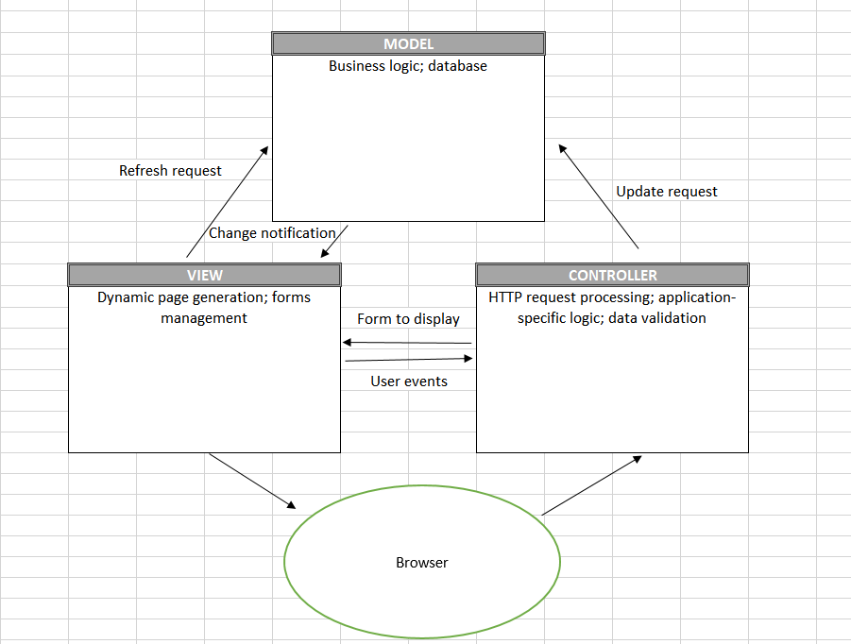

1. Develop and architectural design for student building access

Solution:

For the project, we have chosen the layered architecture

